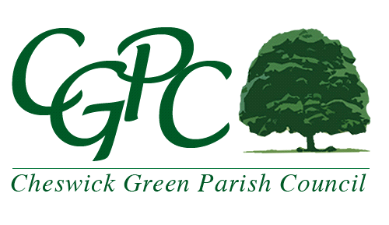
Mrs. Marie Zizzi

Clerk to the Council

Cheswick Green Village Hall

Cheswick Way, Cheswick Green

Solihull B90 4JA

Tel: 01564 700168

clerk@cheswickgreen-pc.gov.uk

www.cheswickgreen-pc.gov.uk

CO-OPTION - FOR YOUR INFORMATION

Two casual vacancies have arisen for Parish Councillors. The successful candidates will serve until the next election, which will be held on Thursday 2nd May 2019 (when the 4-year term of office for each existing Councillor expires). If you would like to be considered for a vacancy it is hoped you will find the following information helpful:

Procedure
- Vacancy notices are displayed on the Parish Councils Notice Boards/website. The Parish Council has decided to co-opt new members from the applications that are submitted to the Parish Council Office.
- If you wish to be considered for co-option please complete the form and return it to the Parish Council Office in the Village Hall.

Responsibilities

- Should you be co-opted then a formal ‘Declaration of Acceptance of Office’ is signed and accepted. Part of the declaration says that you have read, understood and agree to abide by the Code of Conduct for Councillors (available to view on the website). You will also be required to complete and sign a Declaration of Pecuniary Interests form for Solihull MBC.
- You will be issued with a Parish Council email address to enable you to keep all Parish Council information separate and to avoid this affecting your private emails.
- The duties of a Parish Councillor involve attending the monthly Parish Council Meeting (usually the second Wednesday of each month) and serving on a Committee; Recreation Committee, Planning Committee or Staffing Panel. The duration of a meeting can vary between 15 minutes and 2 hours plus!
- Attending a variety of events during the year which you, and your partner, may be invited to, for example, Remembrance Sunday service, inauguration of the Mayor of Solihull, social fundraising events, etc.
- Attending training events to help you fulfil your role as a Parish Councillor.
- Considering the views of the people of the Parish of Cheswick Green when making decisions.
- Representing the Parish Council at meetings of local or regional organisations.

